Eckert 7: sensing the environment
Let op: adhv ppp’s!

- Sensory modality (category sensation), quality (characterize within modality). Chemical, mechanical, electrical, thermal and light → conformational change respective receptor.
- Primary afferent neuron: signal → CNS. Sensory cells selective & amplificatory. Transduction (stimulus → ΔV_{m} membrane → nerve impuls).
- Threshold of detection (50% response). Different response times different types receptors.
- Similarities different receptors (e.g. 7 Transmembrane helices, G-protein coupled R). Enzymatic cascade amplifies.
- Different receptor cells different qualities stimuli. Sensory adaptation (detect persisting stimuli, but still detect Δstimuli). Frequency AP ↔ strength stimuli. Stimulus → graded receptor potential (ionic flow). Phasic receptor (only certain part stimulation; usually onset or offset) vs tonic receptors (continue fire during stimulation).
- Receptor part ion channel or triggers enzyme cascade → channels. Generator potential (receptor potential → modulates APs spike initiating zone).
- Or receptor potential → ↕neurotransmitter. Intensity stimulus↑ → receptor current↑ → receptor potential↑. Tonic spike initiating zone continues producing impulses when depolarized.
- Maximum response limit: (1) current channels, (2) amplitude (Nernst), (3) frequency (refractoriness). Log stimulus intensity → amplitude receptor potential → #APs.
- Broad range: (1) transduction process itself broad range, (2) prolonged exposure → ↕amplification (sensory adaptation), (3) neuronal networks extend individual cells.
- (..)
- Sensory adaptation → perceived vs physical intensity. Phasic (little adaptation): displacement detector; tonic (quick adaptation): velocity detector. Adaptation: (1) mechanical response Δ rather level, (2) receptor molecules run down, (3) feedback enzyme cascade, (4) change electrical properties, (5) spike initiating zone less excitable sustained stimulus, (6) higher order cells. Pacinian corpsule: region mechanical receptor membrane surrounded connective tissue (which mechanically filters fast change and prolonged pressure).
- Cells produce baseline AP and neurotransmitter → (1) stimulation modulates instead threshold → more precise, already steep part sigmoid curve, (2) also decrement #firing possible → directional information. Also noise filtered by summation at central neurons (only simultaneous stimulus detected).
- – 237. (..)
- Mechanoreceptors (mechanical energy → ΔV_{m}, sometimes with accessory structures).
- Mechanoreceptor cell responds stretch or distortion plasma membrane (transduction by cytoskeleton, signal cascades & ion channels themselves). (..)
- Hair cells mechanoreceptors with cilia: 1 kinocilium (9+2 internal microtubules; sometimes lacked mammals, not necessary component; coupling accessory structure), 20-300 non-motile stereocilia (arranged length); stereocilia [toward kinocilium → ↕↕depolarization; away → ↕hyperpolarization] ↔ release neurotransmitter (difference toward/away response enables detection symmetric waves with high frequencies → ”depolarization”). Fishes/amphibia “lateral-line system” (several haircell cilia in “cupula” for flow-detection).
- Statocyst: hollow fluid-filled cavity lined mechanoreceptor cells which contact statolith (object made sand grains, which rests different position ↔ tilt).
- Vertebrate organ equilibrium: sacculus and utriculus, latter gives rise three semicircular canals inner ear (with hair cells same direction in cupula detecting inertia endolymph). Utriculus and sacculus three maculae (more patches hair, with otoliths [↔ statolith]).
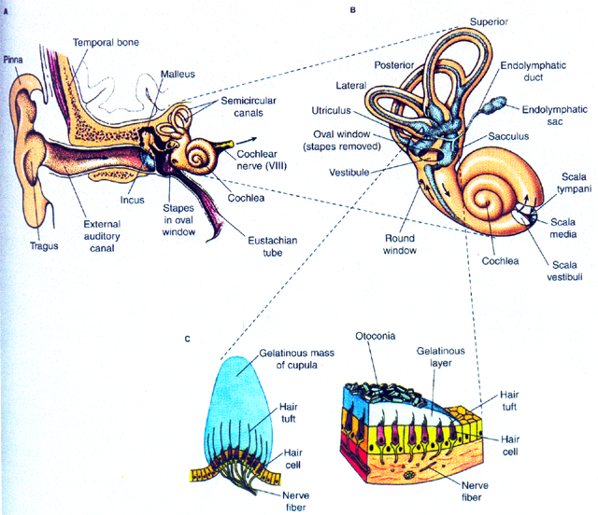
- Pinna & tragus (external structures ear; amplify certain wavelengths & directions). Acoustic impedance mismatch overcome: audio canal → tympanic membrane → auditory ossicles (malleus, incus, stapes) → oval window (amplification → fluid) → cochlea (filled fluid, contains receptor hair cells).
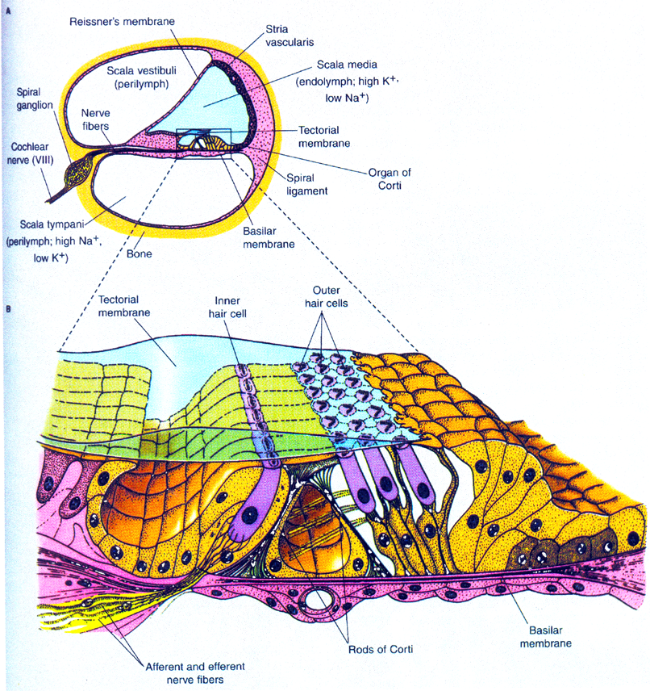
- Cochlea (“shell snail tube”) encased mastoid bone, composed scala vestibuli and tympani (filled perilymph; K⁺↓, Na⁺↑), scala media (filled endolymph; K⁺↑, Na⁺↓; organ of Corti). Some vertebrates detect sound hair cells organs equilibrium.
- Sound oval window → scala vestibuli → scala tympani → round window. [Dependent pitch → part] basilar membrane also vibrates → moves hair cells scala media ↔ tectorial membrane (gelatinous) → ion channels open → excite neurons. Inner row (don’t touch tectorial membrane; transduction), outer row (fine-tuning by modulating properties organ Corti). Cochlear electrical events similar sound.
- Here open channels → influx K⁺ & less Ca²⁺ → depolarization.
- Optimal frequency: (1) long(low ν)/short(high ν) stereocilia, (2) electrical properties cell (electrical resonance frequency = ν max response). Frequency ↔ place membrane. Outer haircells few afferent connections, more efferent synapses: mechanically tuning Corti.
- – 258. (..)
- Cornea (85% refraction), lens (15% refraction; change thickness & curvature → ↕focal length → focus), kept in place zonular fibers, ciliary muscles can relieve tention zonular fibers (accommodation; focus close objects), retina. Binocular convergence (eyes same image).
- Pupil, iris circular (↓pupil) and radial (↑pupil) muscles. Coped with ↕light intensity: sensory adaptation, range fractionation, change state visual pigments. Advantage pupil: outer edges lens optically worse. Rods (dim light) & cones (high resolution, colour in mammals).
- Visual streak (concentration cones). Fovea (/area centralis: high visual acuity). Rudimentary cilium connects outer segment (photoreceptive membranes, lamellae; lumen ↔ cell exterior) inner segment (cell). Rods: lamellae pinch off completely → free floating disks, visual pigments in membrane.
- (..) Dark: equally permeable Na⁺ & K⁺ → dark Na⁺ current because Na⁺/K⁺ pump. Light stimulus → Na⁺ conductance↓ → vertebrate rods and cones hyperpolarize (Nernst K⁺).
- Photoreceptors release neurotransmitters. Light → less release.
- – 267. Visual pigments absorb light (e⁻ higher energy level), consist 2 major components: lipoprotein (opsin) and light-absorbing molecule. Rhodopsins (molecules in which retinal absorbs light; six sugar polysaccharide, phospholipid molecules [>30]), lipoprotein (binds polysaccharide and phospholipids) is integral membrane protein. Light capture: 11-cis-retinal → all-trans-retinal → conformational change opsin → activates G-protein transducin → phosphodiesterase (PDE; enzyme) → cyclic guanosine monophosphate (cGMP; analogue cAMP; dark current channels [Na⁺, Mg²⁺, Ca²⁺] cyclic nucleotide gated) → 5’-guanosine monophosphate (5’-GMP). Dark → cGMP regenerated guanylate cyclase. Light adaptation via retinal intermediates after excitation. Rhodopsin → opsin and retinal, retinal isomerized 11-cis by isomerase, replenishment via all-trans-retinol (Vitamin A₁) and 11-cis-retinol.
- Each photoreceptor 1 class visual pigments with max absorption different wavelength (distinguish colour).
- All visual pigments have retinal as light absorbing group, opsin modulates spectral sensitivity (red & green genes close X-chromosome, differ 15/348 AA). More rods converge 2nd order neuron than cones (→ rods greater summation weak stimuli).
- Rods higher sensitivity vs cones higher acuity. (..)
- Photoreceptors must work against background noise, caused physical phenomena.

